How To Migrate
Dev To Prod
In Android

Document Control
Creation Date: 5/28/2020
Last Update: 6/02/2020
Version: 1.0
Author: Justin Zirkle
Last Modified By:
File Name: New MXP tables - Requirements.doc
Location: \\nclmiami\shares\OnboardRevFinance\ben\mxp\Requirements

TeloCure Migration

VISION
To Bring Innovation For All

TeloCure Internal Use Only
Copyright @ 2020 TeloCure
This copyright notice does not imply publication of this document.

Document Overview

REVISION HISTORY
Version | Date | Description | Editor
1.0 | 5/28/2020 | Initial Document Created | Udoy Jalal Dip
1.1

Open Android Studio update project

Select marked project and Click on it. | 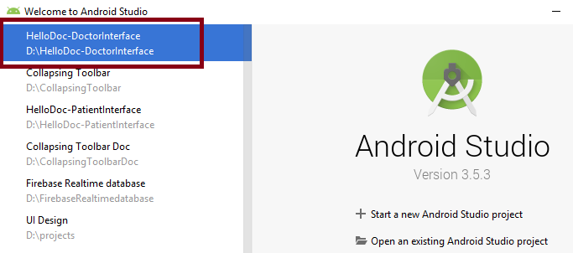
In project, at the left bottom side there is “Terminal”. Click “Terminal” | 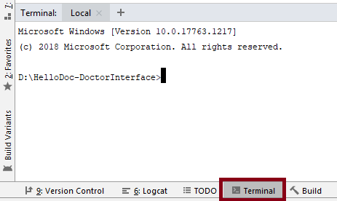
Write, git add . in Terminal and press Enter. | 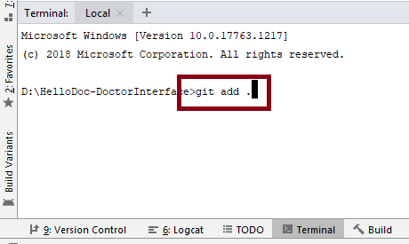
Write, git commit origin -m “message” and press Enter. | 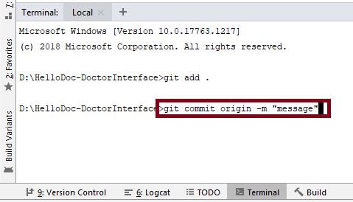
Write, git pull origin master and press Enter | 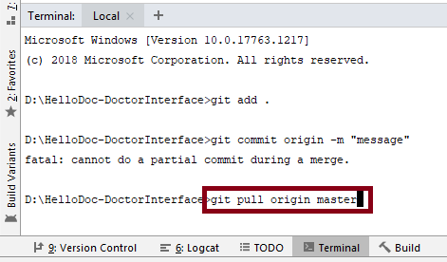
Click Build and wait. | 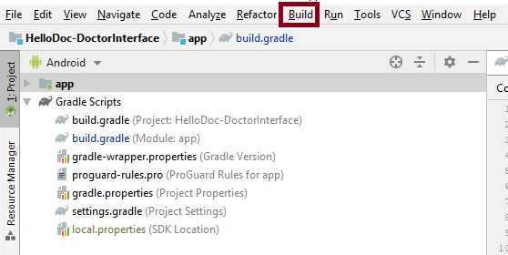

After a Successful run build APK
If it looks as marked, then follow the next steps.  Or if it doesn’t and shows errors contact with Dev team. | 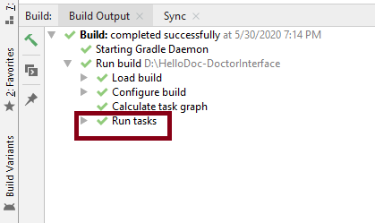
At left will find the marked option. Click on it. | 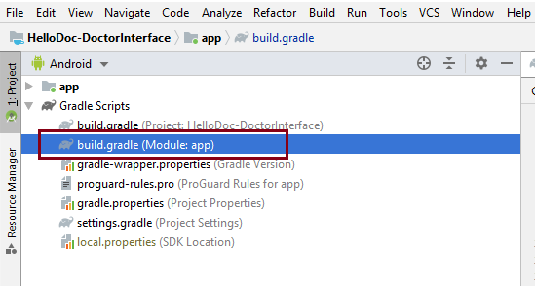
Update the version code. | 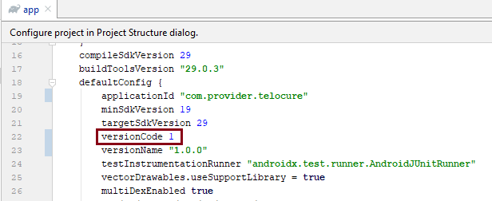
Click on Build. | 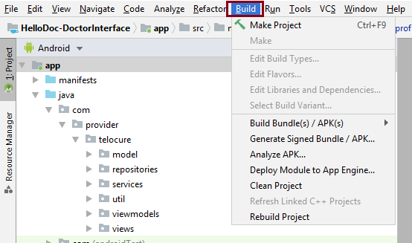
Click on marked option. | 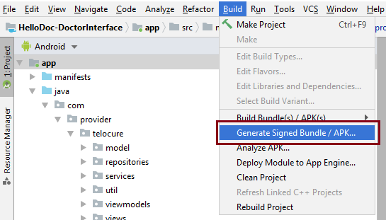
Select “APK” and click “Next”. | 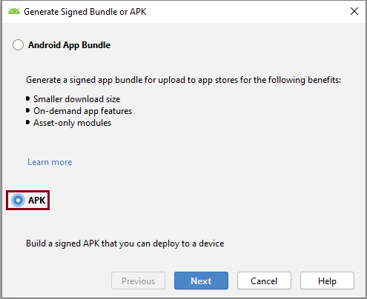

Carefully input the credentials
Give “Key store path” as shown.  Key store password,  stismember1008  Key alias,  provider  Key password,  stismember1008  Click “Next”. | 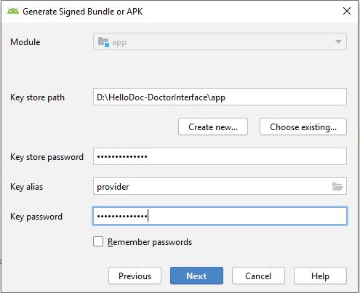
Select “release”  Mark, V1 & V2  Click “Finish” | 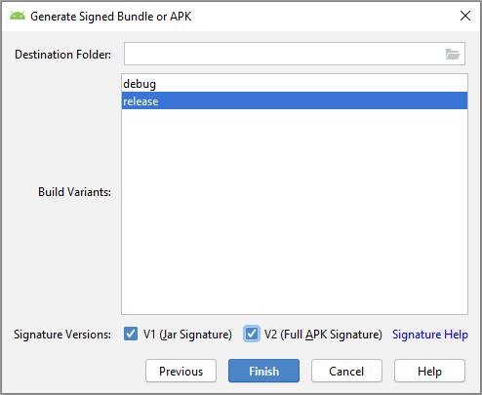
At right bottom click “Event Log” as marked. | 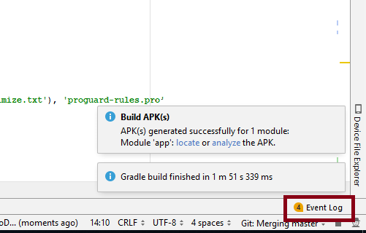
Click “locate”. | 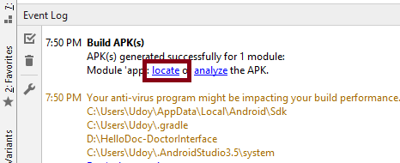
Copy the marked file. | 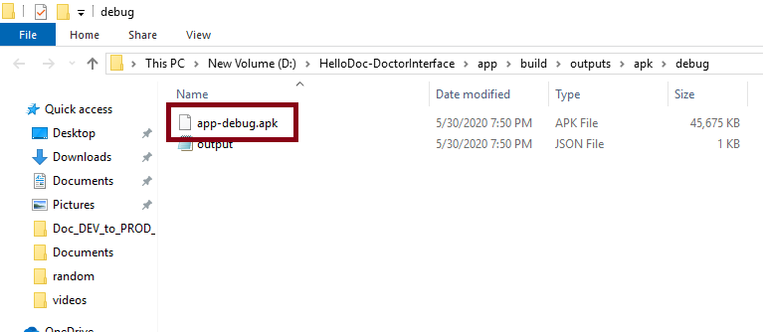
Paste the file in Desktop. | 